Name: Mohamed Aadhil M

Reg.No: 727823TUEC139

Subject Name: Signals and systems

Sub code : 23EC301

Case Study: Image Processing with Signals and Systems Concepts

Objective

The objective of this case study is to explore the application of signals and systems principles in image processing. Students will analyze images as two-dimensional signals, applying various techniques to manipulate and enhance these signals.

Activity Details

1. Analyzing Images as 2D Signals

Understanding 2D Signals: Students will begin by exploring how images can be represented as 2D signals, where each pixel corresponds to a signal amplitude (intensity value).

Image Representation: Discuss the concepts of pixel intensity, color channels, and how images can be converted to grayscale for simpler analysis.

2. Edge Detection Using Convolution

Convolution Basics: Introduce the concept of convolution and how it applies to image processing. Discuss the mathematical representation of convolution in 2D.

Edge Detection Techniques: Students will implement various edge detection algorithms using convolution, such as:

Sobel Operator: Detects edges by calculating the gradient of the image intensity.

Prewitt Operator: Similar to Sobel but uses a different kernel.

Laplacian Operator: Detects edges by finding the second derivative of the image.

Implementation: Using tools like OpenCV or MATLAB, students will write code to apply these convolution kernels to sample images and visualize the results.

3. Filtering Techniques

Low-Pass and High-Pass Filters: Discuss the difference between low-pass and high-pass filters and their applications in image smoothing and sharpening.

Gaussian Blur: Implement Gaussian filtering to reduce noise and smooth images.

Median Filtering: Explore median filtering as a non-linear method to remove noise while preserving edges.

Implementation: Students will apply these filters to images and compare the results, analyzing the effects of different filter parameters.

4. Compression Using Discrete Cosine Transform (DCT)

Introduction to DCT: Explain the concept of the Discrete Cosine Transform and its role in image compression, particularly in JPEG compression.

Compression Process: Discuss the steps involved in image compression using DCT:

Transform the image from the spatial domain to the frequency domain.

Quantization of DCT coefficients.

Encoding the quantized coefficients.

Implementation: Students will implement DCT-based compression in MATLAB or Python, experimenting with different levels of quantization and analyzing the trade-off between compression ratio and image quality.

Datasets for Experimentation

Provide access to a variety of images for experimentation, such as:

Standard test images (e.g., Lena, Barbara).

Real-world images (e.g., nature scenes, urban landscapes).

Noisy images to test filtering techniques.

Skills Developed

Advanced Understanding of System Principles: Students will gain a deeper understanding of how signals and systems principles can be applied in multidimensional contexts, particularly in image processing.

Creative Problem-Solving: Students will face challenges in implementing algorithms and optimizing their performance, fostering creative thinking and problem-solving skills.

Technical Presentation: Each student or group will prepare a presentation summarizing their findings, methodologies, and results, enhancing their technical communication skills.

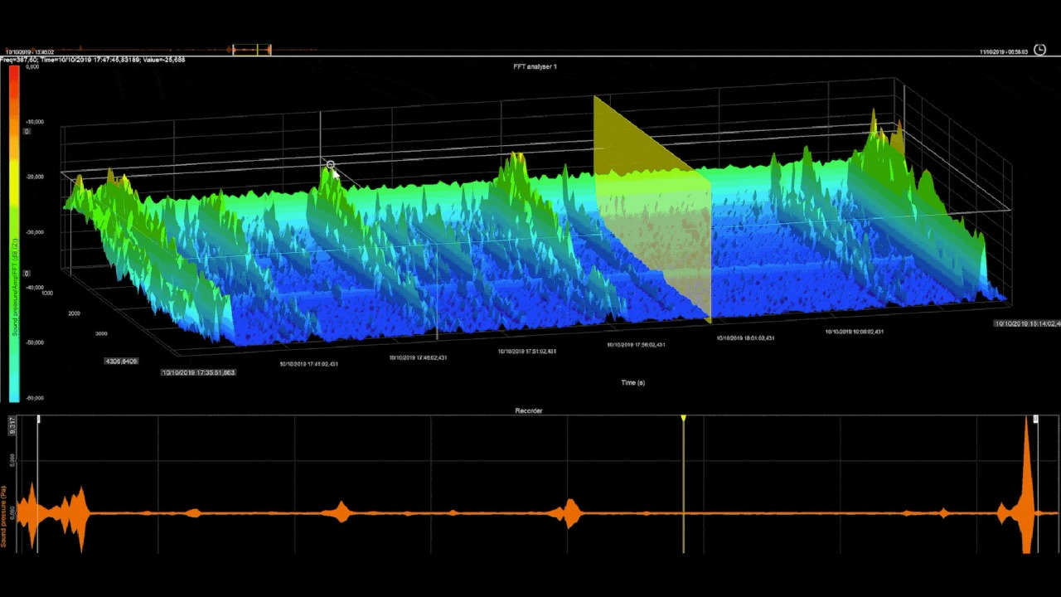

Conclusion

This case study provides a comprehensive approach to understanding the intersection of signals and systems with image processing. Through hands-on experimentation and analysis, students will develop essential skills and knowledge that are applicable in various fields, including computer vision, graphics, and multimedia systems.